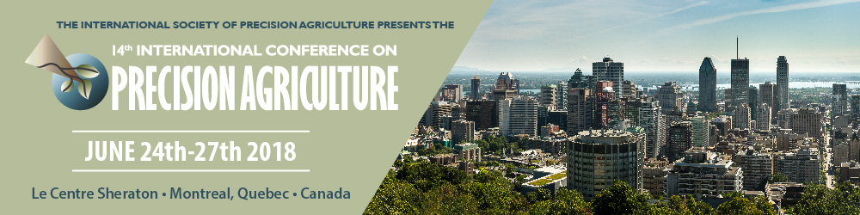

INSTRUCTIONS FOR AUTHORS PREPARING FULL LENGTH PAPERS

NOTE: The online proceedings of the 14th ICPA will provide an enduring, accessible, citable record of your research. All oral presenters are REQUIRED to prepare a full-length manuscript for the conference proceedings. Poster presenters are STRONGLY ENCOURAGED to also prepare a full-length manuscript. Poster presenters please refer to your acceptance email for the alternative paper format.

A NEW PAPER FORMAT IS BEING USED FOR THE 14TH ICPA TO BETTER FACILITATE ONLINE CONFERENCE PROCEEDINGS. CAREFULLY FOLLOW INSTRUCTIONS BELOW AND IN THE PAPER TEMPLATE FILE.

I. PROCESS FOR SUBMISSION

- Name the file with your abstract number and corresponding author name. For example “Abstract 101 John Smith.doc”.
- Microsoft Word is the only accepted file format. Use a PC version of MS Word; sorry NO Macintosh versions.
- Please submit your manuscript online at www.ispag.org/ by May 1, 2018 as per login instructions and password provided via email to corresponding authors of the papers.
- Manuscript must be in a digital “CAMERA READY” format, i.e., fully laid out, with all graphics and figures inline. Tables, graphs, and images should be a part of the document, rather than originating from another software source and must be embedded in the text. For example, do not embed an Excel table and send it with the linked database used to generate the table.
- Absolutely NO faxed manuscripts.
- DEADLINE: MAY 1, 2018.

II. INSTRUCTIONS FOR FULL PAPER

A maximum of 15 pages, "camera ready", single-spaced, including figures, tables, graphs and references will be accepted. Authors must format their paper using the MS Word . The template will be available on or before February 1, 2018.

III. STYLE GUIDANCE

Primary style guidance is provided in the template file given in Section II above. Style for ICPA proceedings papers generally follows the style for the society-sponsored journal, Precision Agriculture. Pertinent information from the Journal style is given below.

Text formatting
- Use a normal, plain font for text.
- Use italics for emphasis.
- Use the automatic page numbering function to number the pages.
- Do not use field functions.
- Use tab stops or other commands for indents, not the space bar.
- Use the table function, not spreadsheets, to make tables.
- Use the equation editor or MathType for equations.
- Save your file in docx format (Word 2007 or higher) or doc format (older Word versions).

Headings
Please use no more than three levels of displayed headings.

Abbreviations
Abbreviations should be defined at first mention and used consistently thereafter.

Additional remarks on text:
- All commercial equipment – give model/number, manufacturer, manufacturer location (city, country).
- Avoid use of personal pronouns / royal ‘we’ – use the passive.
- Preferred length units are mm, m – not cm.
- In text, what was done must be in the past tense.
- All equations must be sequentially numbered.

Scientific style
- Please always use internationally accepted signs and symbols for units (SI units).
- Generic names of drugs and pesticides are preferred; if trade names are used, the generic name should be given at first mention.
- Please use the standard mathematical notation for formulae, symbols etc.:
- Italic for single letters that denote mathematical constants, variables, and unknown quantities
- Roman/upright for numerals, operators, and punctuation, and commonly defined functions or abbreviations, e.g., cos, det, e or exp, lim, log, max, min, sin, tan, d (for derivative)
- Bold for vectors, tensors, and matrices.

Reference citations
Cite references in the text by name and year in parentheses. Some examples:
- Negotiation research spans many disciplines (Thompson 1990).
- This result was later contradicted by Becker and Seligman (1996).
- This effect has been widely studied (Abbott 1991; Barakat et al. 1995; Kelso and Smith 1998; Medvec et al. 1999).

Reference list
The list of references should only include works that are cited in the text and that have been published or accepted for publication. Personal communications and unpublished works should only be mentioned in the text. Do not use footnotes or endnotes as a substitute for a reference list. Reference list entries should be alphabetized by the last names of the first author of each work. Examples for common reference types are given below. For additional guidance, consult papers published in a recent issue of Precision Agriculture.

Journal article
Harris, M., Karper, E., Stacks, G., Hoffman, D., DeNiro, R., Cruz, P., et al. (2001). Writing labs and the Hollywood connection. Journal of Film Writing, 44(3), 213–245.

Article by DOI
Slifka, M. K., & Whitton, J. L. (2000) Clinical implications of dysregulated cytokine production. Journal of Molecular Medicine, doi:10.1007/s001090000086

Book
Calfee, R. C., & Valencia, R. R. (1991). APA guide to preparing manuscripts for journal publication. Washington, DC: American Psychological Association.

Book chapter
O’Neil, J. M., & Egan, J. (1992). Men’s and women’s gender role journeys: Metaphor for healing, transition, and transformation. In B. R. Wainrib (Ed.), Gender issues across the life cycle (pp. 107–123). New York: Springer.

Online document
Abou-Allaban, Y., Dell, M. L., Greenberg, W., Lomax, J., Peteet, J., Torres, M., & Cowell, V. (2006). Religious/spiritual commitments and psychiatric practice. Resource document. American Psychiatric Association. http://www.psych.org/edu/other_res/ lib_archives/archives/200604.pdf. Accessed 25 June 2007.

Additional reference information
- Journal names and book titles should be italicized
- All journal and conference names to be in full.
- For books and proceedings, the publisher and its location (city, country) must be given. Location and dates of conferences should not be included.
- Web references to be followed by ‘last accessed [date]’.
- A maximum of (the first) six authors/co-authors may be listed.

Tables
- All tables are to be numbered using Arabic numerals.
- Tables should always be cited in text in consecutive numerical order.
- For each table, supply a table caption (title) explaining the components of the table.
- Identify any previously published material by giving the original source in the form of a reference at the end of the table caption.
- Footnotes to tables should be indicated by superscript lower-case letters (or asterisks for significance values and other statistical data) and included beneath the table body.

Artwork and illustrations guidelines
Figure lettering
- To add lettering, it is best to use Helvetica or Arial (sans serif fonts).
- Keep lettering consistently sized throughout your final-sized artwork, usually about 2–3 mm (8–12 pt).
- Variance of type size within an illustration should be minimal, e.g., do not use 8-pt type on an axis and 20-pt type for the axis label.
- Avoid effects such as shading, outline letters, etc.
- Do not include titles or captions within your illustrations.

Figure numbering
- All figures are to be numbered using Arabic numerals.
- Figures should always be cited in text in consecutive numerical order.
- Figure parts should be denoted by lowercase letters (a, b, c, etc.).

Figure captions
- Each figure should have a concise caption describing accurately what the figure depicts.
- Figure captions begin with the term Fig. in bold type, followed by the figure number, also in bold type.
- No punctuation is to be included after the number, nor is any punctuation to be placed at the end of the caption.
- Identify all elements found in the figure in the figure caption; and use boxes, circles, etc., as coordinate points in graphs.

